Chapter – 3
StyleNova-Multi-Brand-Fashion-Lifestyle

Customer entity:
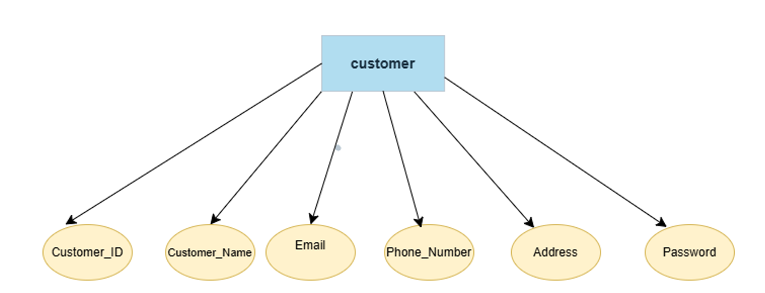
Seller entity:
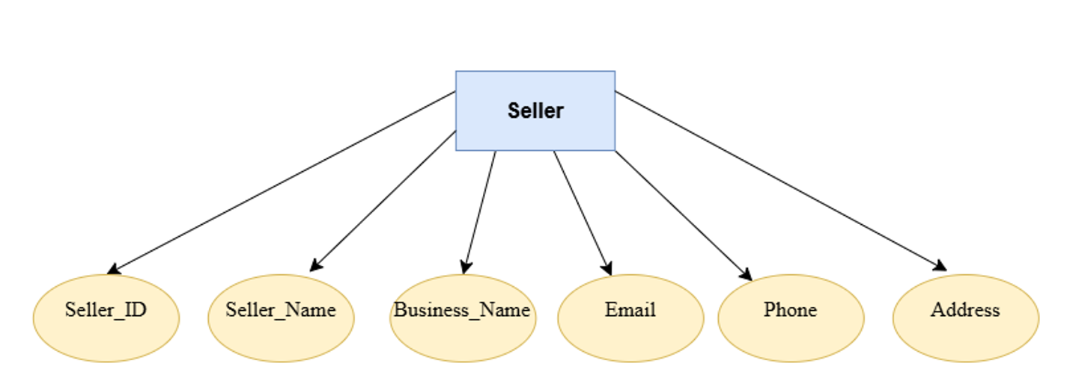
Product entity:
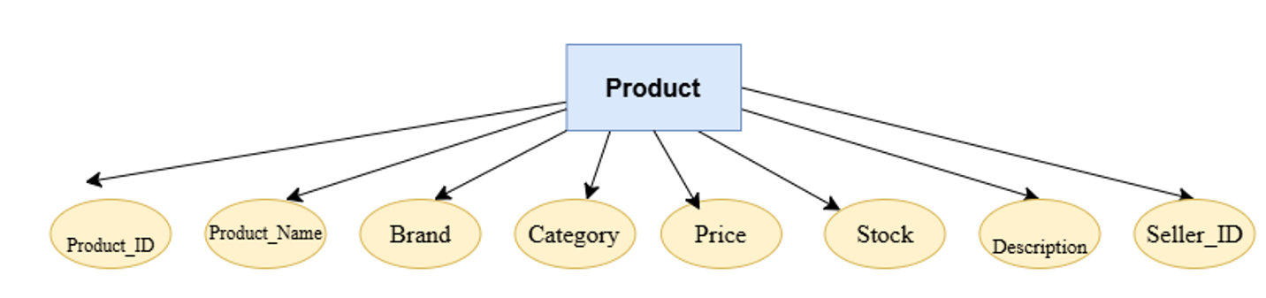
Order entity
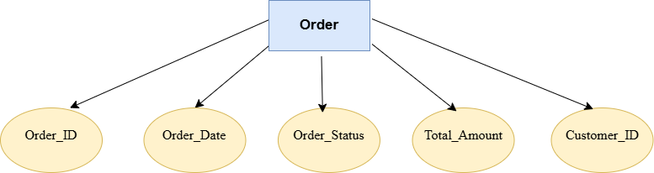

Payment entity:
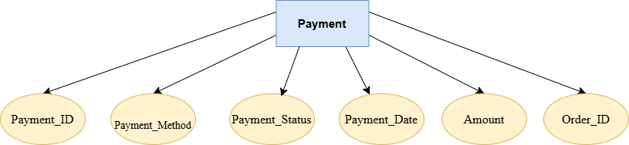

Inventary entity:
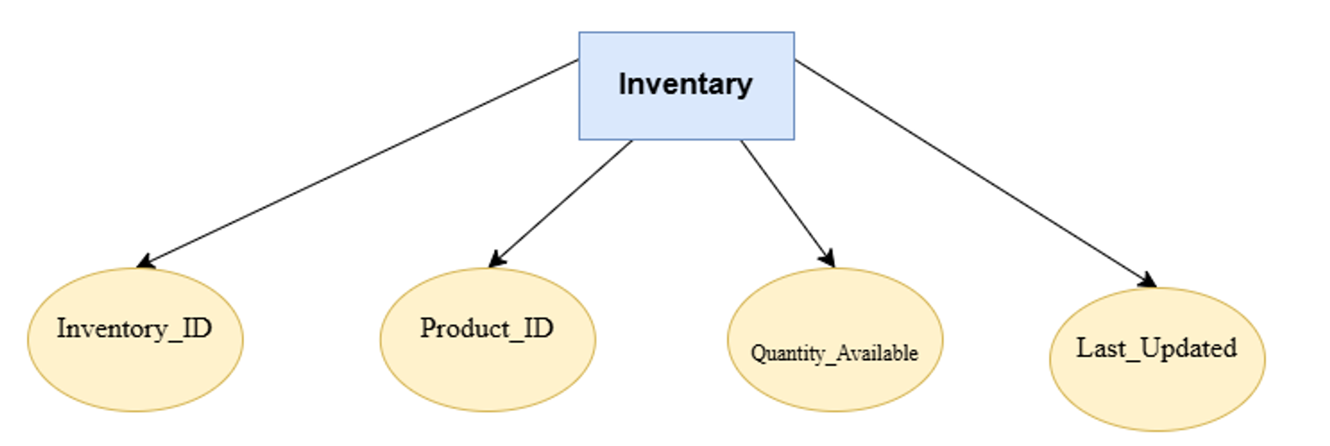

Review entity:
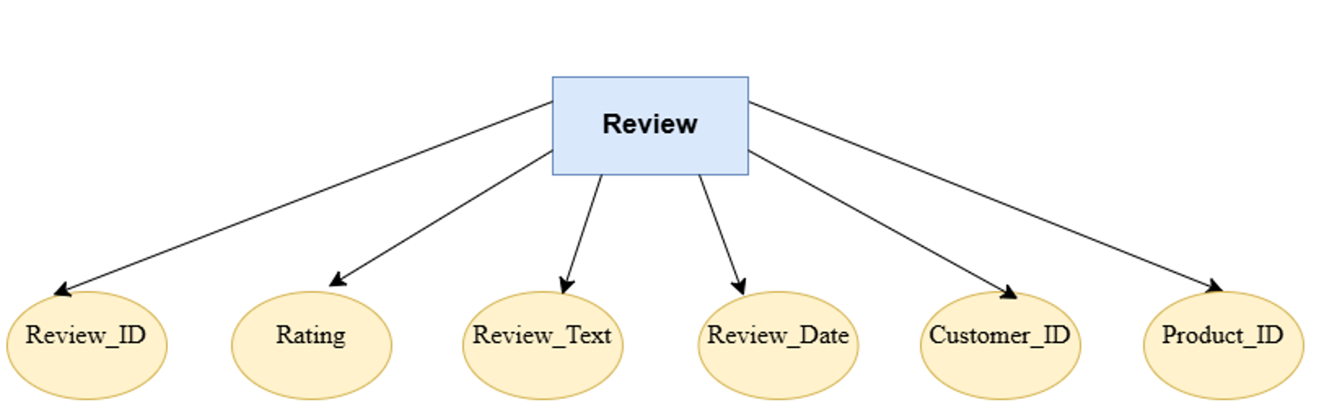

Relationship entity:
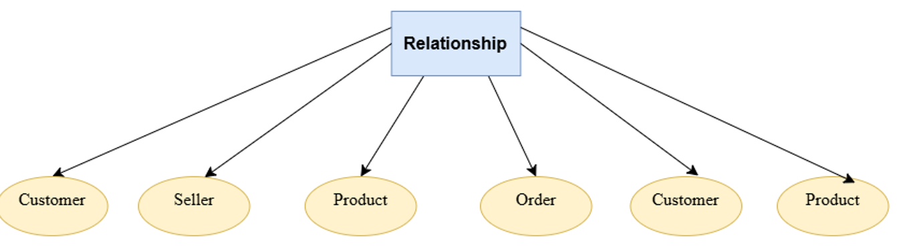

Relationship diagram:
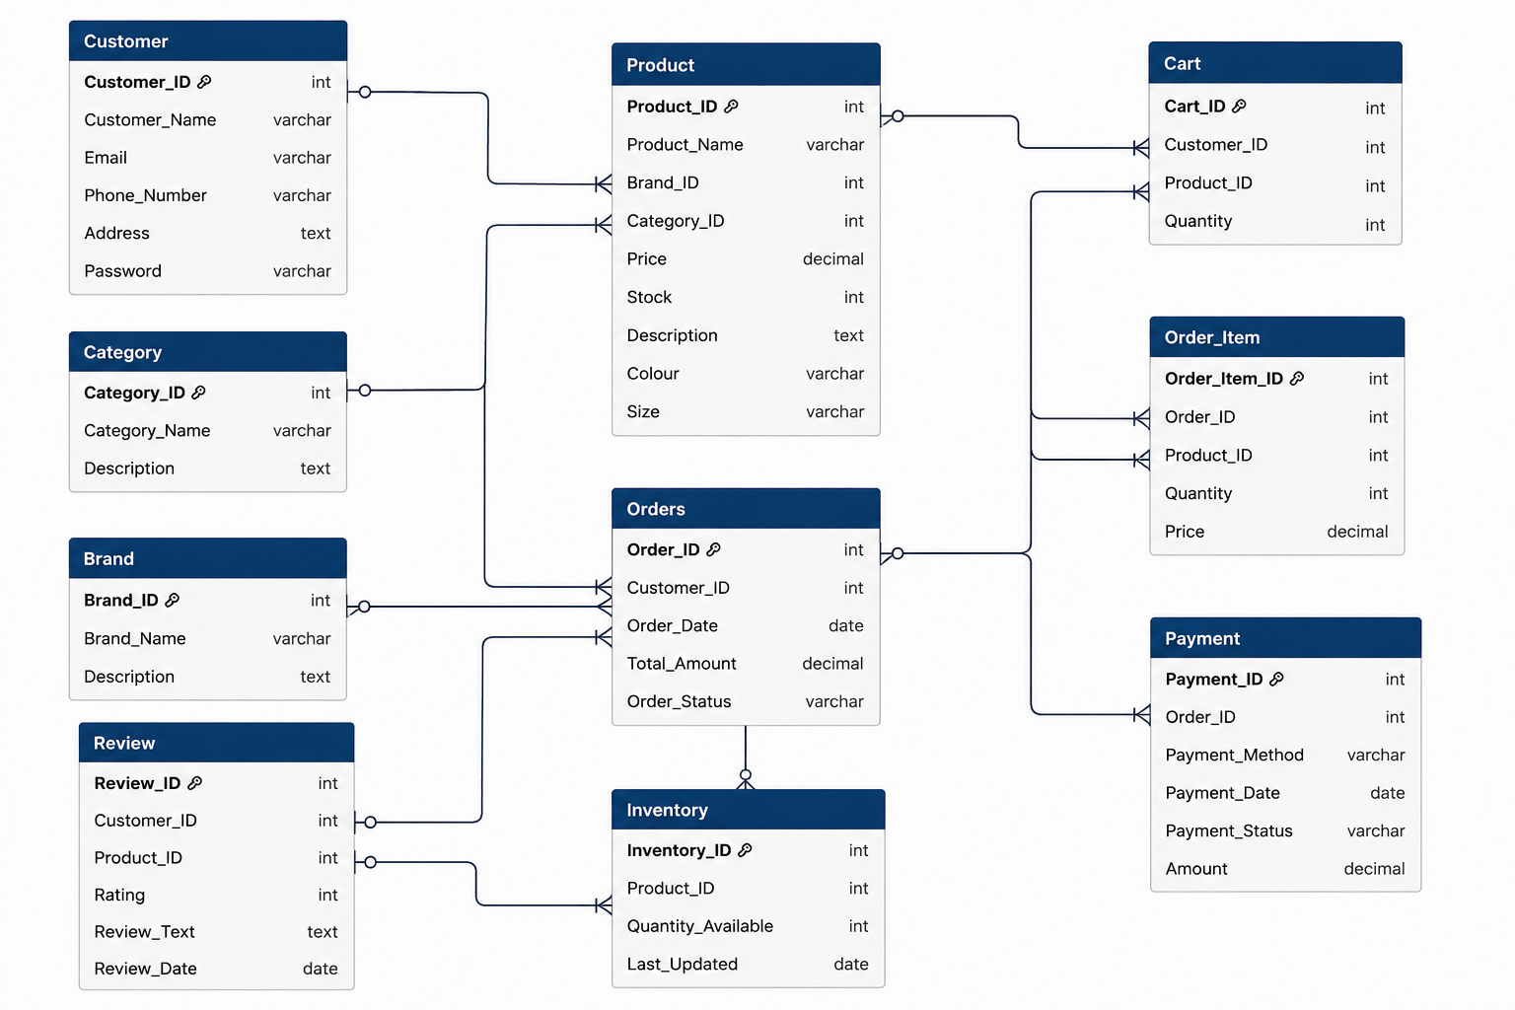

Entity Relationship Diagram:
